Requirements

In viewing Sarah’s user story and the use case diagram, the application should incorporate the following functionality.

* Get the Geo-location of the user.
* Provide the ability to pull from a backend database. (This would enable a user to view the artist profiles).
* Use local storage on the device to save profile data, which has been pulled from a back-end database.
* Create an API. (The API will use Geolocation as a search criteria, to provide results of profiles within a user’s vicinity).
* Use a third party API to pull songs which align with a user’s music tastes.
* Get push notifications to notify a user if a new artist arrives in their local area.

Use Case Diagram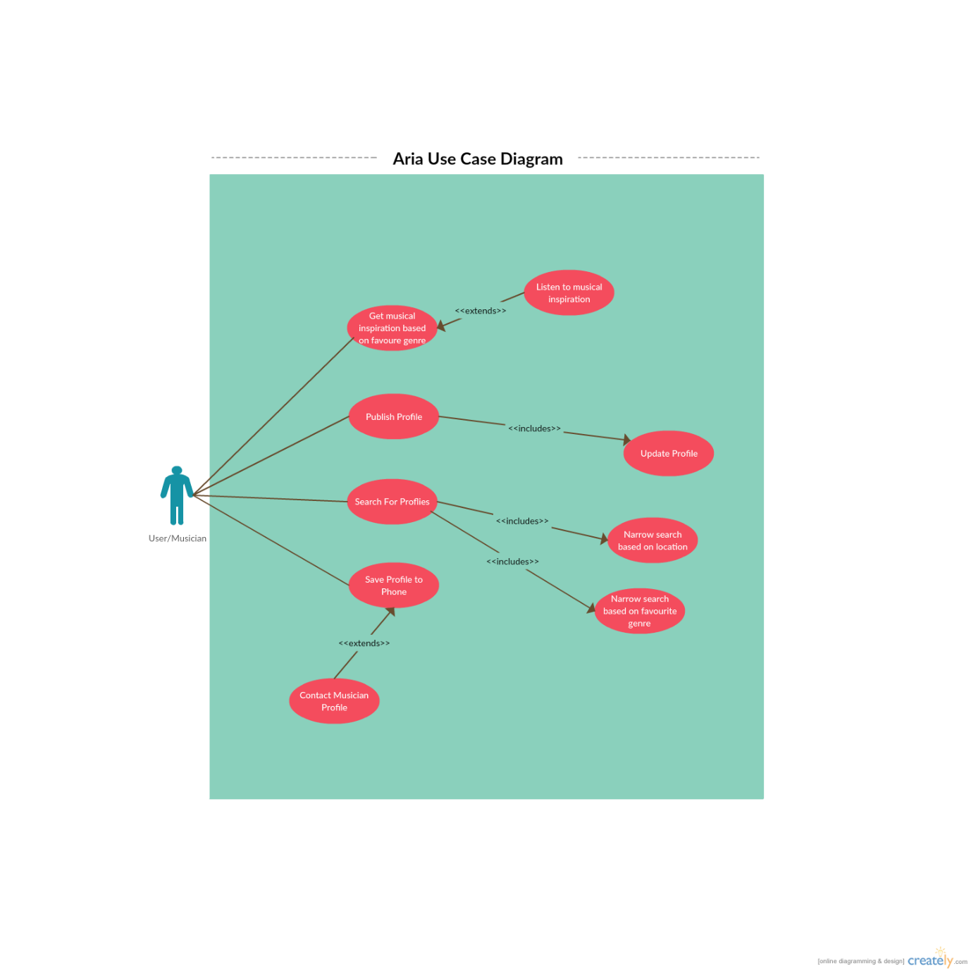

**Mood boards**

After deciding the functionality of Aria, it was not yet understood how the app would look. The first step to forming idea entailed creating a series of mood boards. Subsequently, the meanings of each were interpreted, and tied back to how they could be used in the aesthetics and map of Aria. All three boards have different chariteristics, which have all contributed to the finished verison of Aria.

**Mood board 1**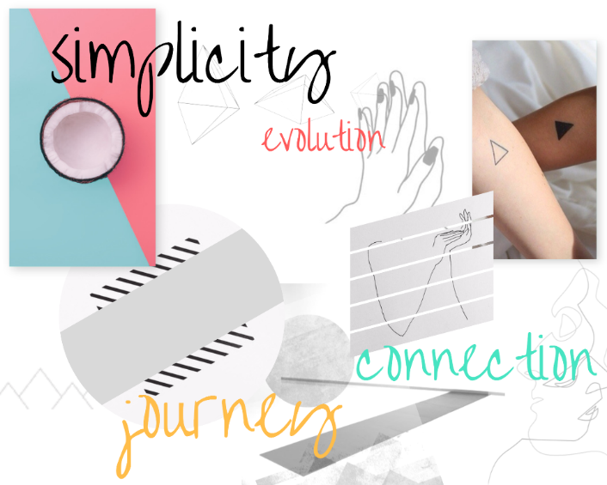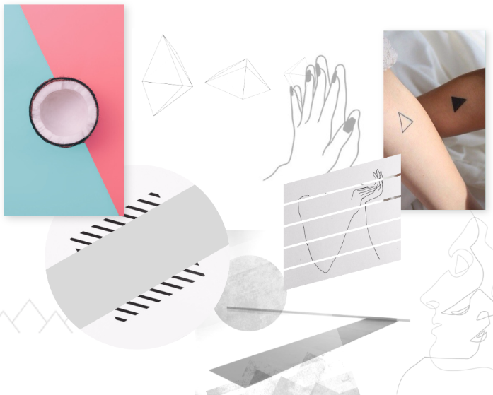

The first board explores disorder, with 10 pictures spriadically placed around the canvas and an abundance of white space. All images within the canvas feature no more than two items. This formation displays a level of simplicity. Simplicity is a strong UX feature to application design and one which Aria would have to inhibit to be operated quickly operated by a user. Many pictures within the canvas encomass a theme of connection. In terms of design, Aria takes this theme and tries to make its user base feel connected. In terms of a colour theme, this moodboard has a mainly white palet, with the occasitoal flash of colour (Cocunt). If Aria followed this theme is could have appeared modern is style, but also ran the risk of appearing bland.

**Mood board 2**

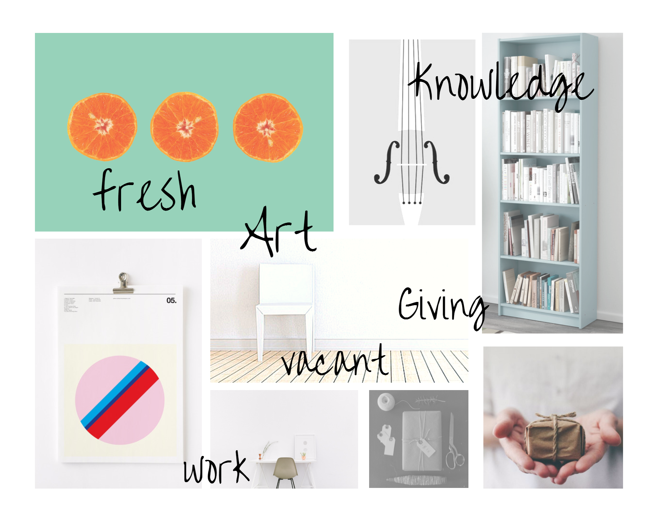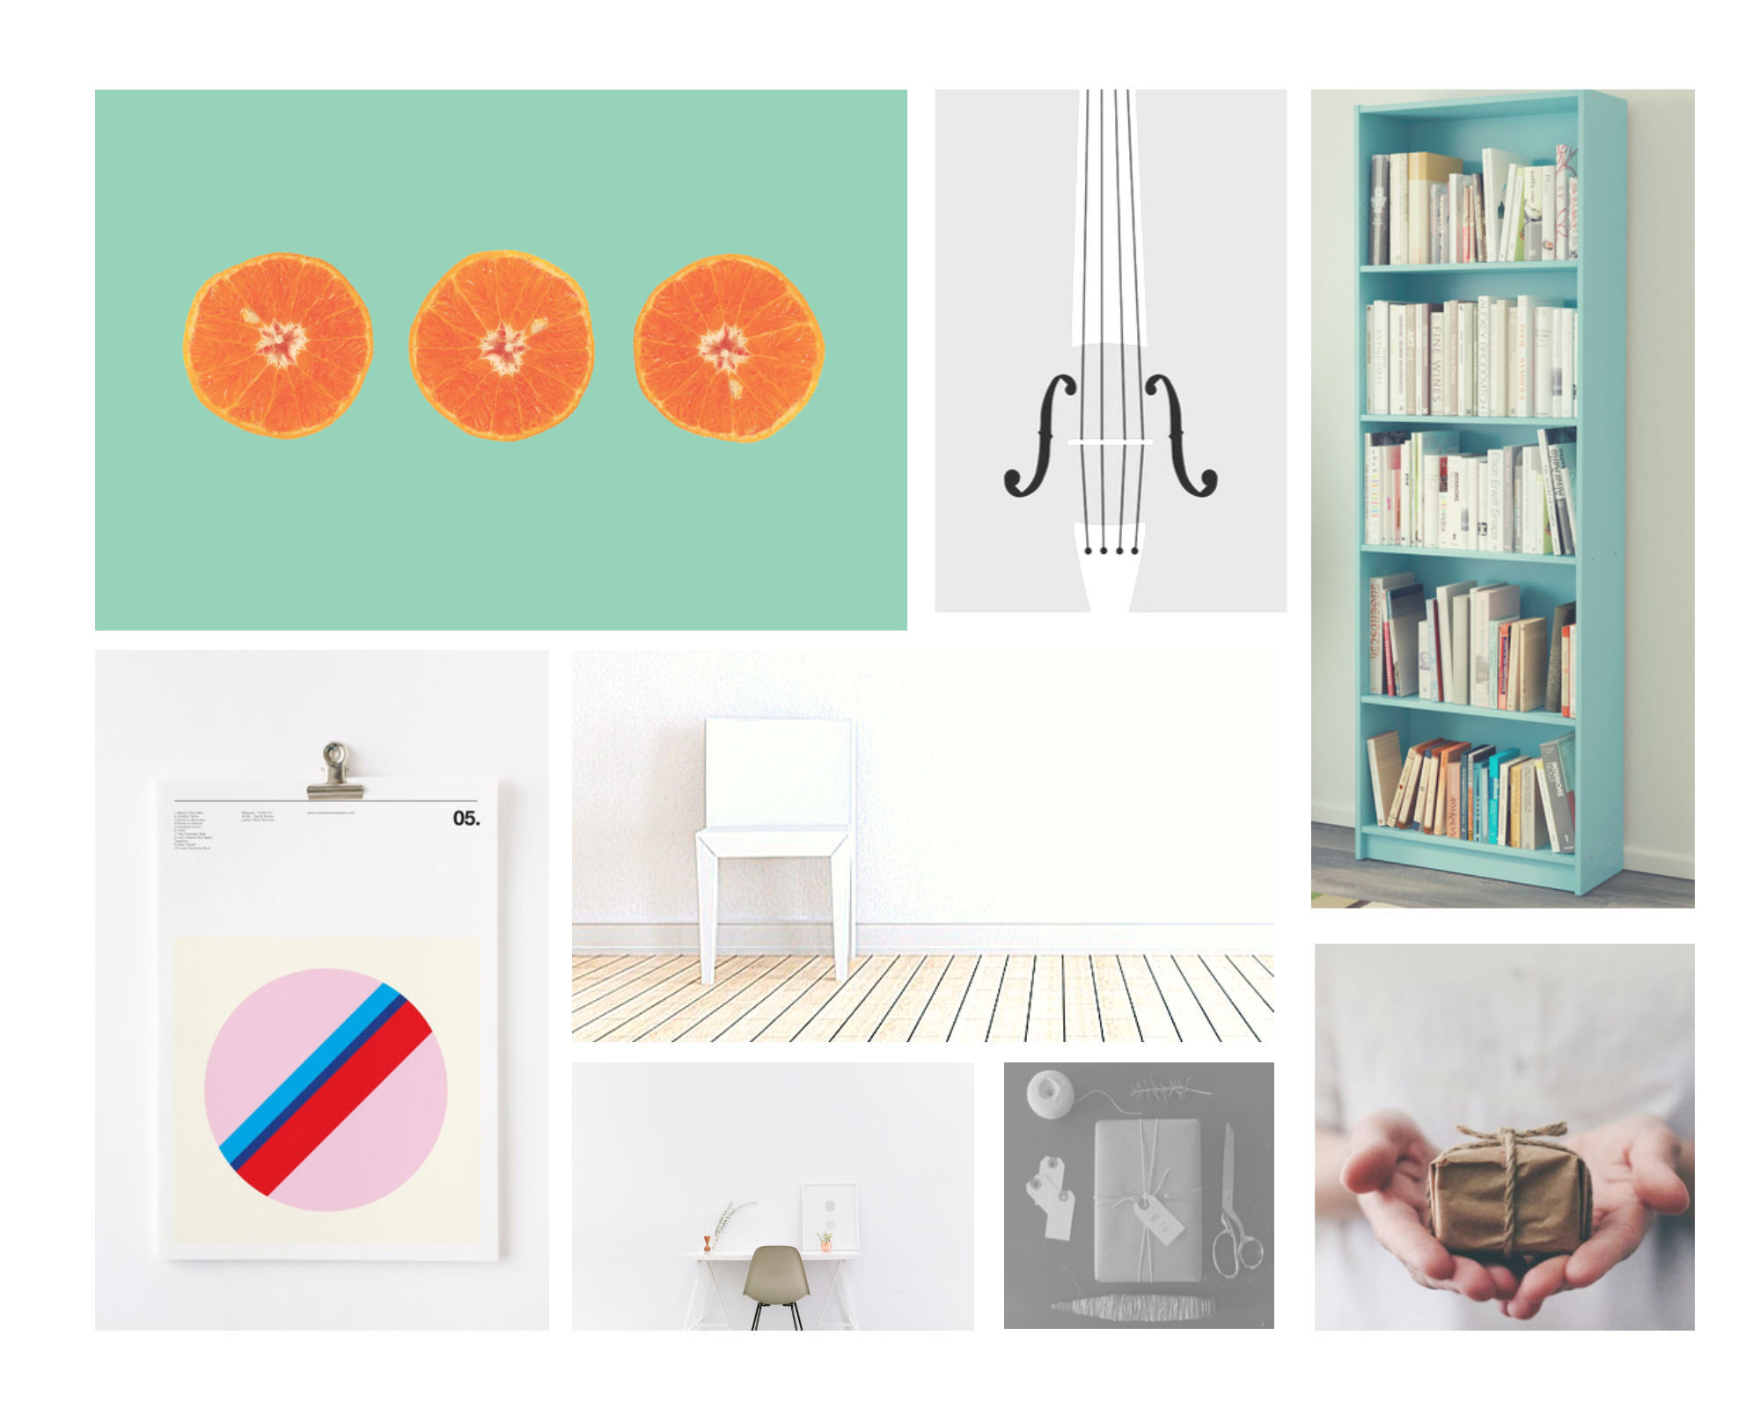

This board inhibits a more ordered style but still promotes the theme of simplicity and space. In constrast to moodboard 1 it provides a sense of ‘Giving’. In light of this, Aria has tried to provide the user with an *experience* as oposed to a *utility*. The canvas is also artistic in nature, which corrilates well to Aria’s user base of creators.

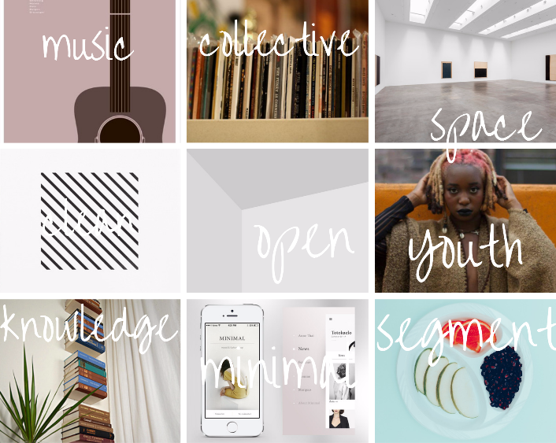**Mood board 3**

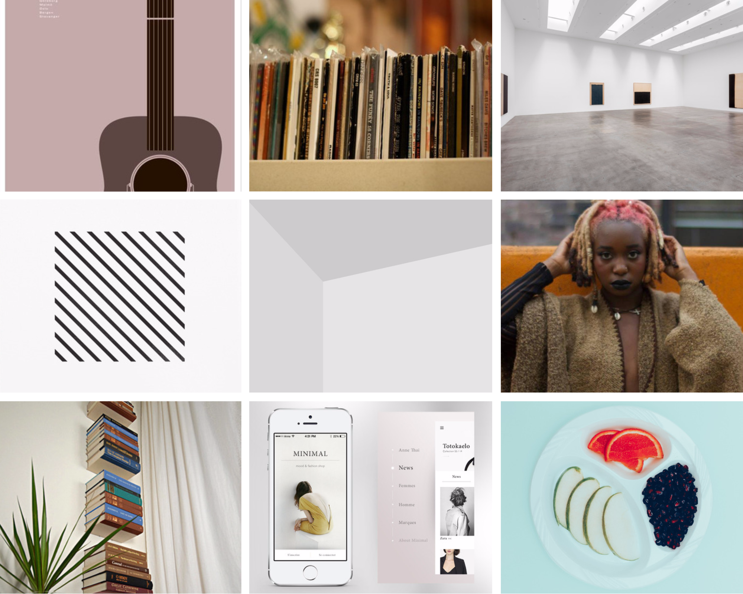

In terms of colour pallet this canvas is darker than the others. This dark tone has been incorporated into the first and final design of Aria. It is also the most ordered, with each section incomporating their own micro theme. On a macro level this has also been applied to Arua, with functionality spreading across multiple pages to enforce simplicty.

This section will display the development process of Aria, highlighting improvments on each iteration. Each protype has been evluated based on their fucntionality and peer review.

**Iteration 1**

As shown in **figures … to …** the first Lo-Fi prototype for Aria was created using the method of paper protoyping and Hi-Fi mock ups made in photoshop.

The title screen has a bold text ‘Aria’ at the top with a single gateway button at the bottom. The background also is noted as having a video background (evidently this cannot be conveyed). The intention here is to give the new user a positive first impression, and to display the kind of experience they could receive if using the application. It was understood that the title page had a low amount of functionality. This is a clear trade off between aethetics and access to core functions (searching/publishing music profiles).

The details page **figure…** enables users to enter their personal information. The single button at the bottom is designed to present the main page, sending the users information to a server and pulling other artist profiles down.

The main page is comprised of two sections. The top half features the map potion, whilst the bottom half displays a horizontal list of artists the user’s vicinity.

A list item is displayed as a card element containg a picture and name of the given artist.

The information page **figure..** is designed to store all the saved items. The page displays a list of cards of similar size to those in the “main page”. However the design of the cards are different. Three different Lo-Fi designs have been drafted.

* Design A: Has a black background, displaying a picture floated left and artist information on the right.
* Design B: Has an artist picture as the background image. This certainly jumps out more to the user, however still displays a lot of information all at one time.
* Design C: Includes an artist picture and name. However in contrast it provides the option to show information text of the given artist. This design seems to segment the information in a simple intuitive way.

Evaluation of Iteration 1

After implementing the iteration onto a Hi-Fi design it was reviewed by a two musicians. Both musicians felt there were improvements which could be made. In reading the documentation it is evident that more information had to be provided about each musician on the main page. This is reasonable since it is trivial to implement and helps the user make a more informed decision as to which musicians to save. On the other hand in adding more information to the page, it does take away from the simplistic design we are trying to create. It has also been noted that there is a lack of a navigation bar. Both musicians felt a navigation bar would be more intuitive to use than a making gestures. The Hi-fi prototype also lack back end functionality, which is evidently required to display the user with a pool of artist profiles.